**Injured – Hospital**

**Doctor Sonia**

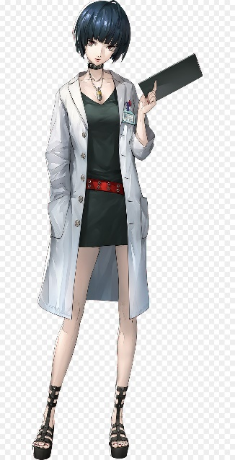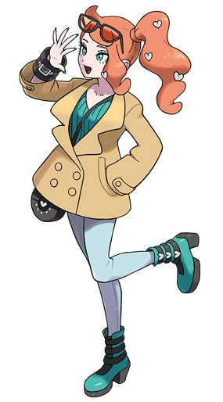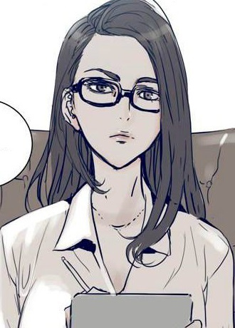

Nothingness envelops you. You can’t feel your arms, your legs, your body… only a light, ethereal floating sensation in an endless void of darkness. It’s almost… calming.

With no indication of the passage of time, you don’t feel anything. Days have passed… or is it weeks? Years? You’re not sure, but somehow you feel at peace. Maybe this is fine, staying here like this…

“Hey.”

There is a voice in the darkness, disrupting the tranquility. You feel your brow furrow in response to the sudden sound. Oh, you can feel your brow. And your face. Slowly, you feel the rest of your body come back to you, as if your consciousness had drifted back into it.

“You’re awake, aren’t you?”

Your eyes flutter open.

White. With light grey specks. The first thing you see is the ceiling of a hospital ward. You squint as your eyes adjust to the white light shining directly down on you. You slowly realize you are lying down in a hospital bed.

In your peripherals you see a figure, standing by your side. From your perspective, its features are cast in shadow.

“Officer ${name}, yes?” The voice is feminine, with a… Western accent, you think. The figure scribbles something on a clipboard.

You begin to try and sit upright, but only get a third of the way there before a sharp pain jolts you. It’s almost as if pure lightning was passing through your innards, making its way up to your brain. You grimace at the pain, collapsing back into the bed.

“Whoa there. Easy now.” A pair of gentle arms catch you, and gently positions you in an upright sitting position. The light aroma of cinnamon enters your nose as the figure reaches over to help you.

With the light no longer shining directly into your eyes you can now make out the features of the mysterious individual.

The lady that stands by your bedside has smooth, dark brown hair, almost maroon, flowing down to her lower back. A few strands help to frame her peach-toned face. Her seafoam irises are aimed downwards at her clipboard, which she has returned to writing on. She has a slender build, though you struggle to make out much ‘curvature’ because of the long white lab coat that hugs her from her shoulder to just above the knee. Underneath her coat she wears a simple olive tank top and black leggings.

After a few more moments of rapping on the clipboard, she turns up to look at you, her gaze analyzing you. “Commander, you can call me Doctor Sonia, you can thank me for nursing you back to life.”

#Thank you so much.

*set relationship_sonia +1

“No worries. To be honest, your body did most of the heavy lifting. You’re rather lucky to have survived from a wound like that.”

#...

“The silent type huh. That’s fine.”

#Where am I?

*goto hospital_where_am_i

*label hospital_where_am_i

“This is the Haris James Hospital, in Giralmore. You and your men were brought here from Orlotek 4 days ago. From what I’ve been told, you were in a fight against LOM forces and… well, seemed like you guys didn’t do too well.”

Right… Orlotek, Liberators of Morovia…

Memories of the fight flash before you. Memories of your failure. Memories of your men’s bodies hitting the ground, unmoving.

Your chest tightens, and your breaths get heavier. Your body starts to tremble inexplicably.

“Hey now-“ Sonia says, putting her clipboard down.

Her words are muffled to you. Your mind is flooded with dark visions of bloodshed and gore. The blood swarming around you, choking you… your chest hurts, you want to scream-

Suddenly a wave of spice hits your nose. The powerful aroma of cinnamon envelops you, pushing away those dark thoughts and embracing you in its comforting presence.

You snap back to reality to see Sonia leaning forward, waving a stick of cinnamon in front of your face. Her expression is calm and gentle, encouraging you with a small smile.

“Smells good doesn’t it? It’s my favourite. I like giving them out to my patients, helps them calm down.” Seeing you return to your senses, she places the spice into your palm. She then pulls a wooden stool over and sits by your side, as your breathing slows and returns to its regular pace.

“It’s the middle of the night right now, unfortunately for you. Having been out of it for 4 days straight you’re probably not ready to go back to bed anytime soon. I guess [i]little ol’ me[/i] will have to keep you company.” A mirthful smile spreads across her face. It’s clear she’s trying to lighten the mood.

*label smalltalk_sonia

#Cinnamon huh… it smells really good.

*set relationship_sonia +1

“Glad you like it. It’s a trick my mum taught me. I’ve had anxiety since I was a little kid, and every time I had a bad day, she would make a cup of cinnamon tea for me. The smell helps me re-centre myself, I guess. I keep a whole bundle with me at all times.”

Sonia reveals the underside of her lab coat, showing off an inner pocket full of cinnamon sticks.

“Feel free to ask if you want more. I have a whole stash of them in my office. It’s kind of become an obsession at this point.” The doctor chuckles quietly to herself, recalling better times.

#W-wait it’s nighttime?!

There were no windows, so you wouldn’t have guessed.

The doctor chuckles lightly, but gestures at you to lower your volume. “Yes, all the other patients are asleep so please keep it down. These walls are anything but soundproof.”

Other patients… it dawns on you that you don’t know the whereabouts of your men. Or if they even survived.

Doctor Sonia seemingly reads your mind. “If you’re worried about your guys, don’t. The injured ones are downstairs recovering steadily. I think the rest have been sent back to your camp.”

#I’ll [i]gladly[/i] spend the night with your Dr Sonia~

*set relationship_sonia -1

Her smile vanishes, replaces pursed lips forming a straight line.

“Don’t push it, bub.”

Sonia crosses her legs. She picks up a cup of tea that was waiting atop the bedside table – cinnamon tea, no doubt.

She indulges in a sip.

“Anywho, we’ve got some time to kill before the sun comes up. Tell me a little about yourself.”

*goto mc_backstory

**Win – Barracks**

**Sergeant Kosnik**

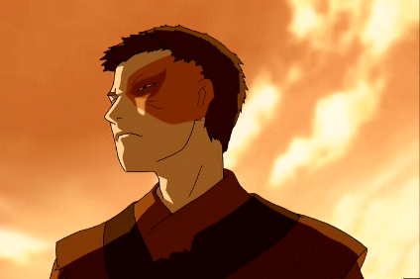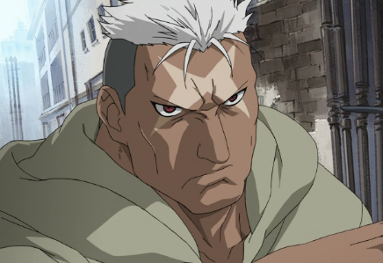 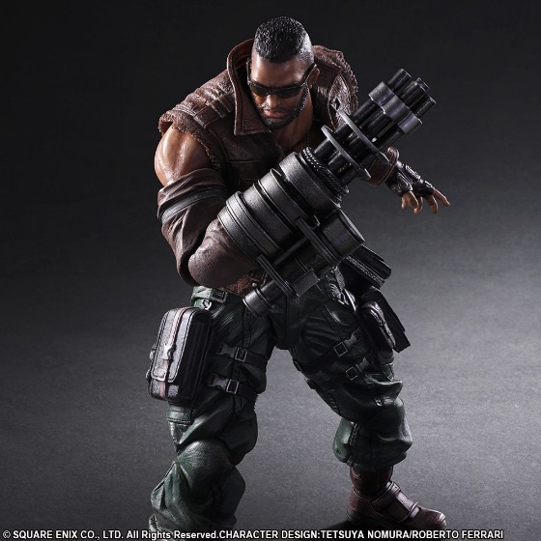

Dust billows around you. At some times it stings your eyes, but you ignore the pain, continuing to stare into the plumes of yellow cloud.

After emerging victorious from your fight in Orlotek, you radioed for reinforcements to come and pick you up. After an hour or so, several trucks pulled up to town, and several soldiers piled out of them to sweep what was left of the town. You and your men piled into the backs of one of the trucks, and began moving back to base.

Right now, you sit near the tail end of the open vehicle, watching the road stretch endlessly behind you. The tires pick up the dust on the road, creating large clouds of pale yellow smoke.

Most of your men retreat inwards, near the front of the truck, but you remain. You’re barely aware of the fine grains that are beginning to coat your entire body, as you allow your mind to wander.

“Commander.”

A voice snaps you out of your thoughts.

You turn around to see Sergeant Kosnik sitting across you. With his helmet off, you can now clearly see his features. His bald, dark-skinned head is also being coated with the dust, but the soldier doesn’t seem to care. An old scar stretches across his masculine features, starting from the top-left of his forehead down to his upper lip. The salmon coloured blemish mars the left side of an otherwise handsome face.

A hand-rolled cigarette hangs loosely from his lips, smoldering. He extends his arm to offer you a cigarette and Zippo lighter.

#Accept the cigarette and take a puff.

*set relationship_kosnik +1

You graciously accept the offer. Placing the white stick between your lips, you flick the lid off the small metal rectangle. It produces a meek fire, shivering in the wind. Shielding it in your other hand you raise the flame to the cigarette to light it, watching as it curls into a bright ember.

A long drag.

It feels good to drift, to allow the mind to wander away from the death and loss of the morning.

You toss the lighter back to Kosnik with gratuitous thanks. That really hit the spot.

#Refuse politely.

You raise your hand to indicate that you’re good, but smile and nod to show that you appreciate the offer.

Kosnik shrugs, pocketing the goods.

#”Serg, don’t smoke in the vehicle.”

*set relationship_kosnik -1

Kosnik gives you an incredulous look.

“I don’t want to be breathing in that second-hand smoke, and neither do the rest of your guys.” you explain.

“Seriously?” Kosnik mutters under his breath. He pockets the lighter and cigarette, takes one pull from the lit cig in his mouth before chucking the rest of it out onto the road.

*goto kosnik_intro

Kosnik takes a long drag from his own cigarette. You watch the glowing end inch ever so closely to his fingers, before he removes the stick from his mouth to exhale a thick cloud of smoke.

*label kosnik_intro

He chuckles. “Got to hand it to you, Commander, I thought we were goners back there.”

“Somehow, with your help, we made it out of there, but…” Kosnik trails off, his expression hardening, not meeting your gaze.

“You ever think that we… we shouldn’t have survived?”

His words are barely audible over the roar of the engine and the howls of the wind, but they reach you. Kosnik unconsciously touches the scar on his face.

#”We fight to protect our loved ones. Gotta live to keep doing that.”

*set relationship_kosnik +1

“I don’t know too much about that ‘should’ or ‘shouldn’t’ have part,” you begin slowly, sensing the sensitivity of the topic.

“But personally, I’m fighting for the people I love back home. I want to protect their way of life. To do that, I have to survive. That’s what keeps me going.”

A moment passes, as Kosnik looks out at the road passing rapidly under and beyond the truck.

He turns to look at you, a smirk on his face. No words are exchanged, but he resonated with your sentiments.

#”It’s a basic human reaction, the need to survive. Who’s to say we should or shouldn’t have?”

Kosnik ponders about it for a moment, scratching the light stubble on his chin.

He laughs to himself, shaking his head, seemingly giving up on finding an answer.

#”Something about that scar bothering you?”

*set relationship_kosnik +1

He jolts upright, his hand quickly returning to his side.

“N-nah! Just itchy, that’s all.” he jokes.

Kosnik’s a bad liar, you find out.

The awkwardness in the air is almost palpable.

Kosnik scratches the back of his bald head, ready to switch subjects.

“Anywho, if we’re going to be working together from now on, it’d be good to know more about each other right? What’s your story?”

*goto mc_backstory